FAZAIA BILQUIS COLLEGE OF EDUCATION FOR
WOMEN PAF NUR KHAN, RWP

Parallel Distributed Computing (LAB)
Lab 2 Tasks
Submitted to
Ma’am Iffat

Submitted by
Javeria Fazal
BSCS 7th B
F21-62

Task 1
1. Ask the user to input their name.
2. Use a for loop to print numbers from 5 down to 0.
3. Pause for 0.5 seconds after printing 5.
4. Pause for 1 second after printing each of the other numbers.
5. After the countdown, print: Welcome <username>
- Source Code:
using System;
using System.Threading;
class Program
{
static void Main()
{
// Ask user to input their name
Console.Write("Please enter your name: ");
string username = Console.ReadLine();

// Loop to print numbers from 5 down to 0
for (int i = 5; i >= 0; i--)
{
Console.WriteLine(i);
if (i == 5)
{
Thread.Sleep(500); // Pause 0.5 seconds after printing 5
}
else
{
Thread.Sleep(1000); // Pause 1 second after printing other numbers
}
}

// After countdown, print welcome message
Console.WriteLine($"Welcome {username}.");
}
}

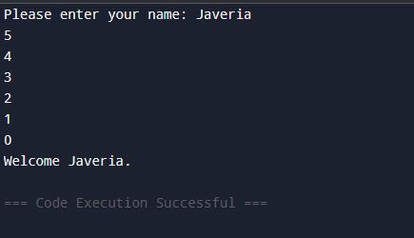
- Output:
Figure 1
Task 2
Write a C# program that simulates Pac-Man moving across a single line.
• Pac-Man (C) should eat the dots (.) one by one.
• When Pac-Man reaches a dot, the dot should blink (disappear briefly) before Pac-Man moves forward.
• Use Thread.Sleep() for timing.
- Source Code:
using System;
using System.Threading;

class Program
{
static void Main()
{
string Line = "..........."; // dots Pac-Man will eat
int length = Line.Length;
for (int i = 0; i < length; i++)
{
Console.Write("\r" + new string(' ', i) + "C" + Line.Substring(i + 1));
Thread.Sleep(200); // Pac-Man arrives
Console.Write("\r" + new string(' ', i + 1) + "C" + Line.Substring(i + 1));
Thread.Sleep(200); // Dots disappear (blink)
}
Console.Write("\r" + new string(' ', length) + "C"); // Pac-Man at end
Console.WriteLine("\n\nGame Over! Pac-Man ate all the dots");
}
}

- Output:

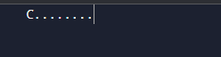


Figure 2
Figure 3

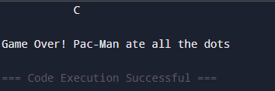

Figure 4
Task 3
Create a C# console program that simulates rainfall animation using ASCII characters.
• The rain should be shown with . or | symbols, displayed in multiple frames that update in sequence to create the effect of falling drops.
• Only one frame should be visible at a time, and the animation should repeat for a fixed number of loops before ending.
- Source Code:
using System;
using System.Threading;

class RainSimulation
{
static void Main()
{
// Define multiple frames for animation
string[] frames = new string[]
{
@"
. . . .
. . . . .
. . . . . .
. . . . . .
. . . . .
. . . . . . .
",
@"
. . . . . .
. . . . .
. . . .
. . . . . . .
. . . . . . . .
. . . . . . .
",
@"
. . . . .
. . . .
. . . . .
. . . . . . .
. . . . . . .
. . . . . . .
. . . . . .
"
};

Console.CursorVisible = false;

- Continued:
// Loop to repeat animation
for (int i = 0; i < 50; i++) // Run for some time
{
foreach (string frame in frames)
{
Console.SetCursorPosition(0, 0);
Console.WriteLine(frame);
Thread.Sleep(100); // Adjust speed as needed
}
}

Console.CursorVisible = true;
}
}

- Output:
(It will be like raindrops falling at run time)


Figure 5

